Field visit to NIPER incubation center

Date: 22.12.2022
No of participants – 50 students (M.Pharm first year)
No of faculty members- 03.

Nirma University incubation center organized a field visit to the NIPER Incubation center - Gandhinagar on 22nd December 2022 for the first-year students of the Master of Pharmacy, IPNU.

The main objective of this visit is to promote a culture of innovation, research, and entrepreneurship among students and to formalize them with the research-equipped laboratories of your incubation Centre with the latest research and innovations in the field of biotechnology. Mr. Hariom, Manager, of the incubation centre NIPER discussed about the establishment of the NIPER incubation centre, he also discussed the role of the Incubation center in nurturing business ideas. He explained to students how incubation center supports startups in mentoring, getting patents and commercialization of the project. Students visited the laboratory facilities developed by NIPER for research and development.

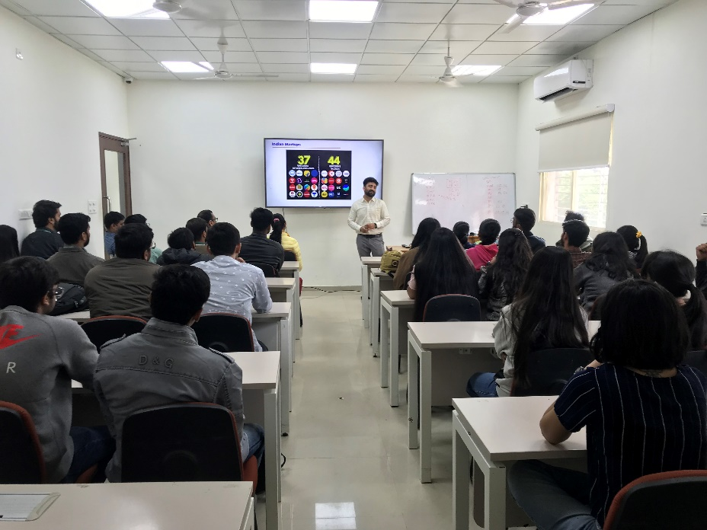
Orientation session
